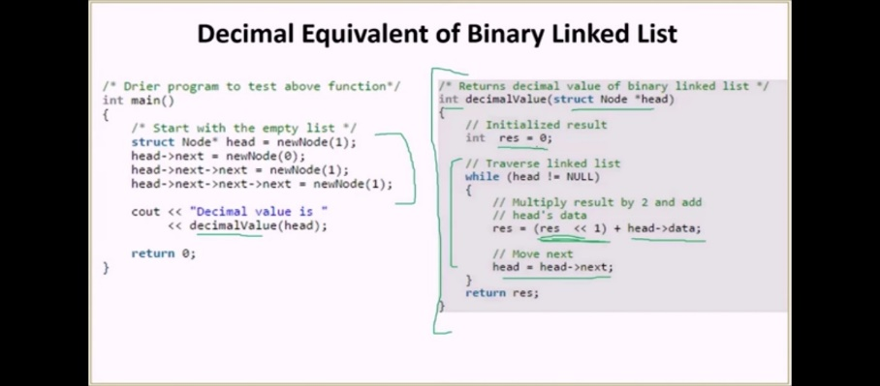
Initialize the result as 0. Traverse the linked list and for each node, multiply the result by 2 and add the node’s data to it.

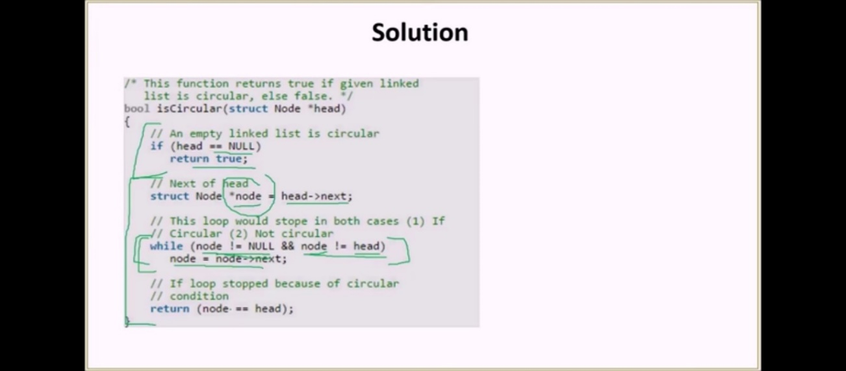

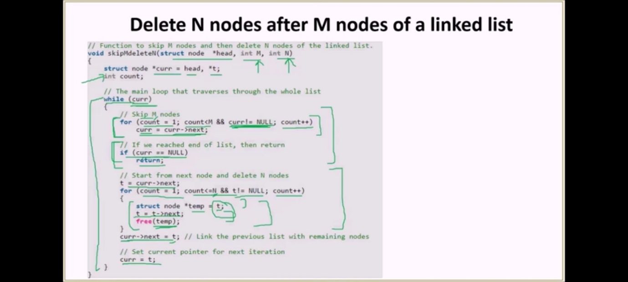
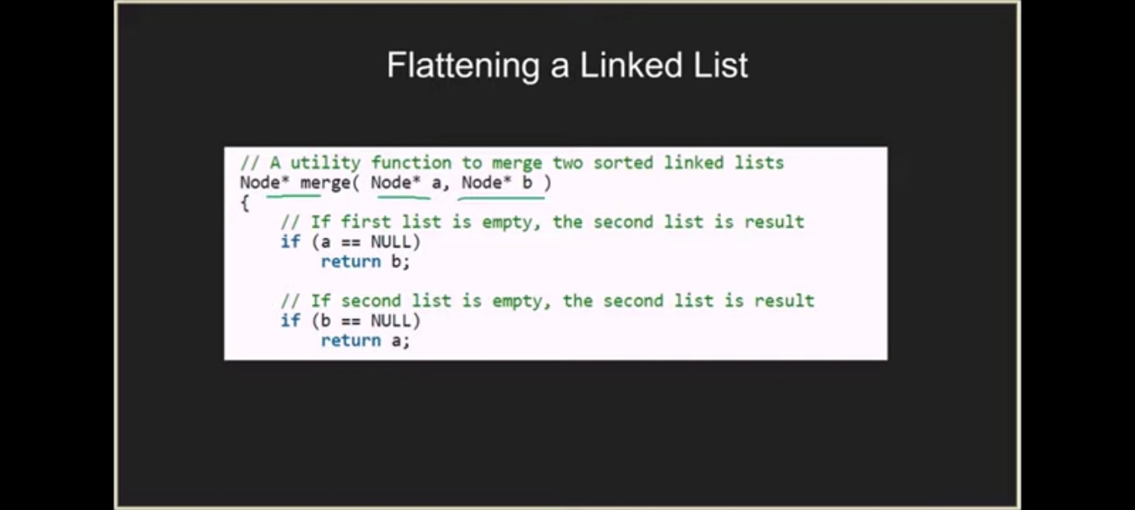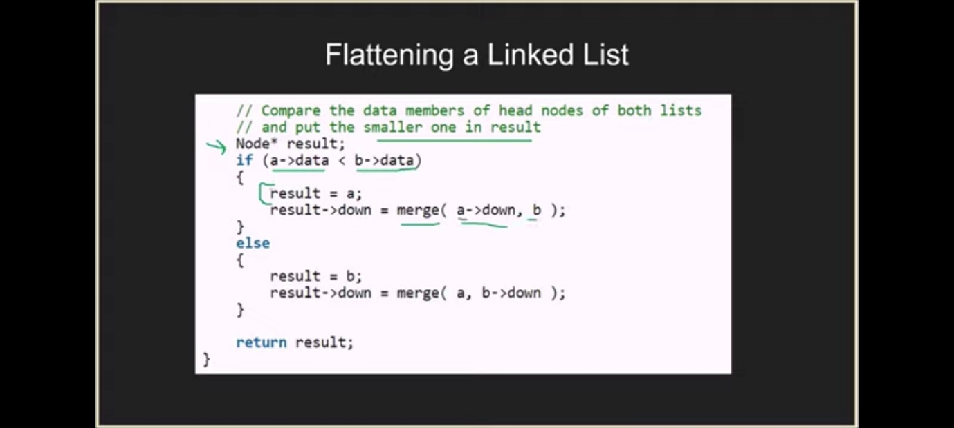
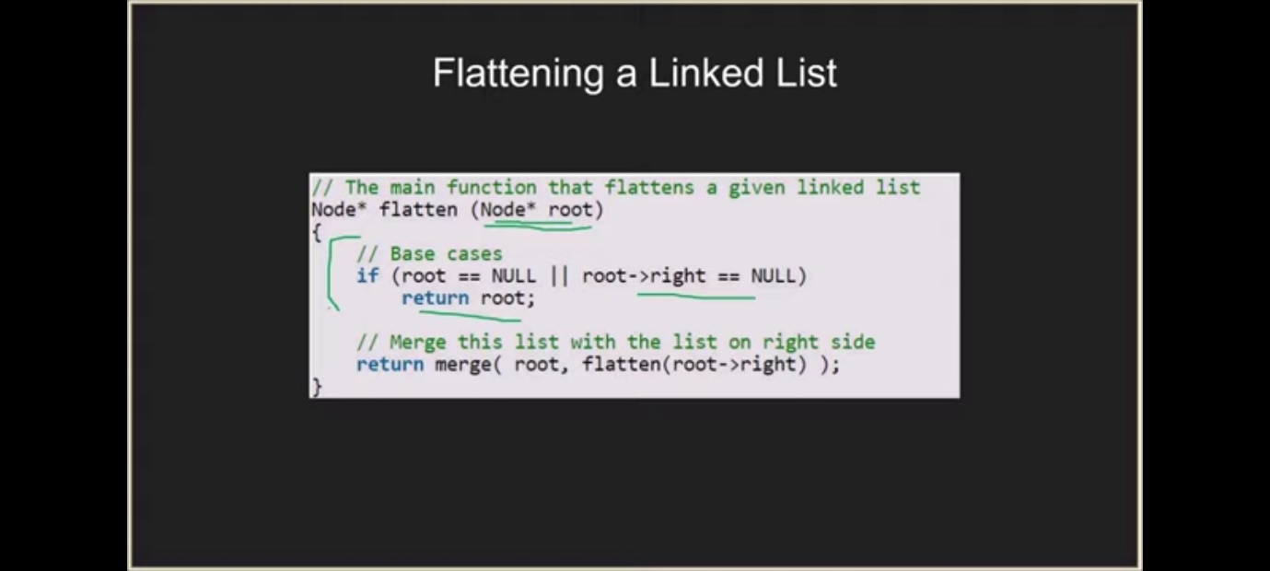
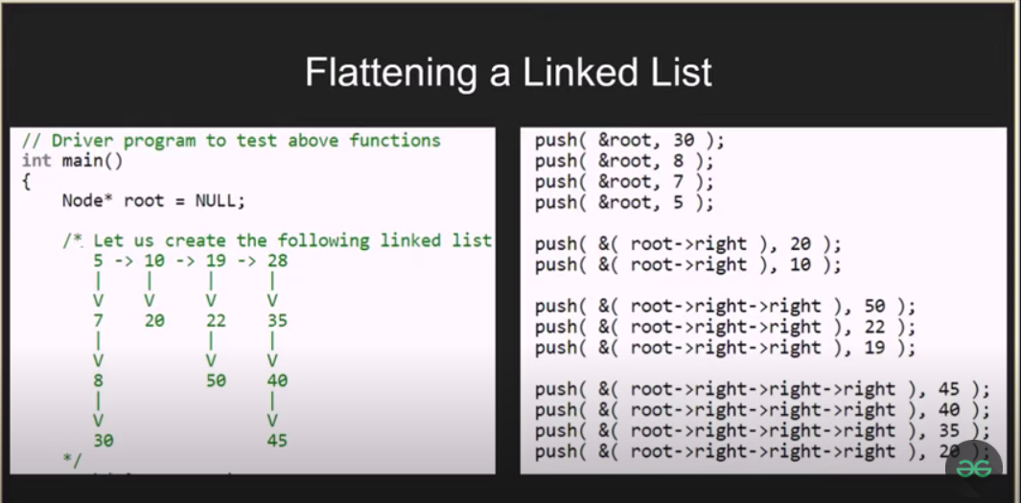
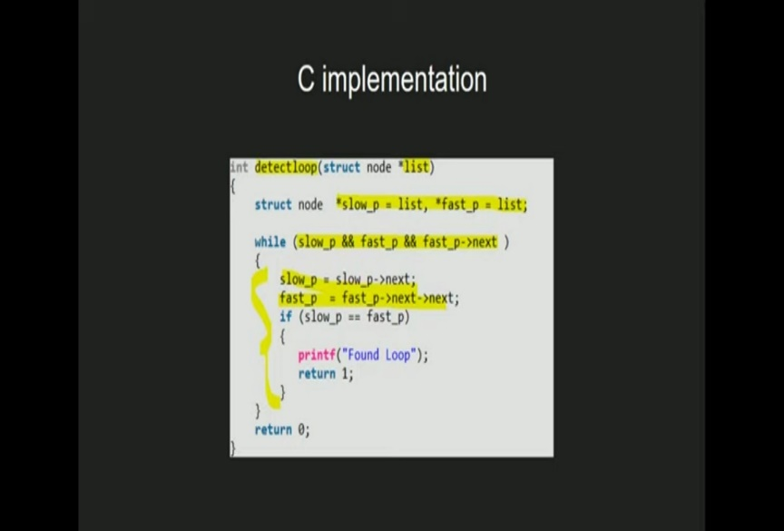

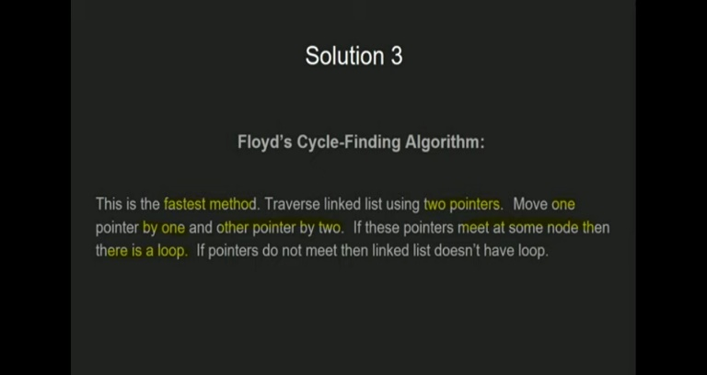


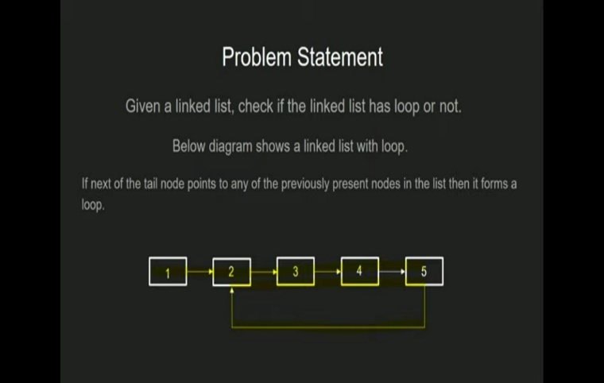
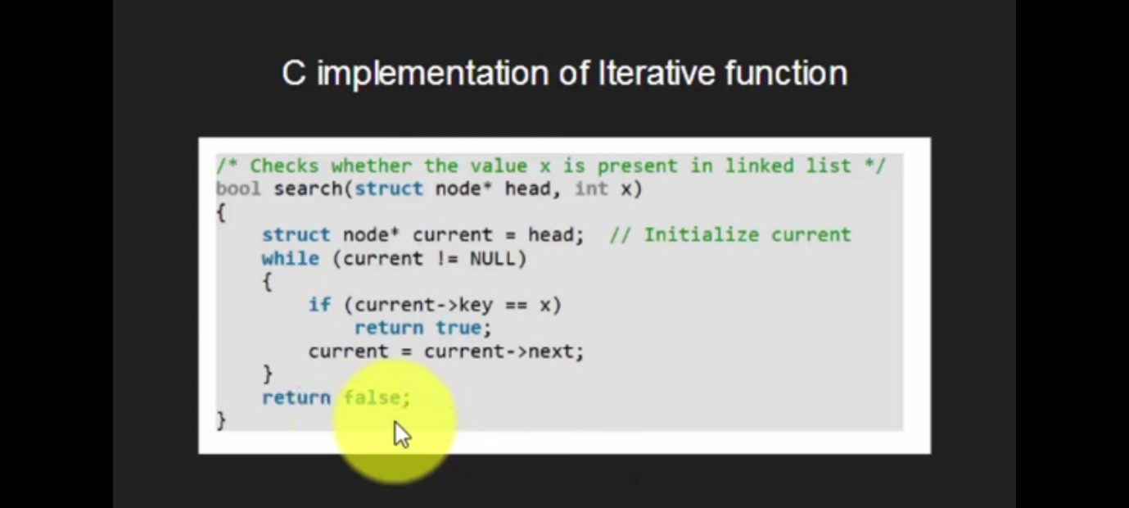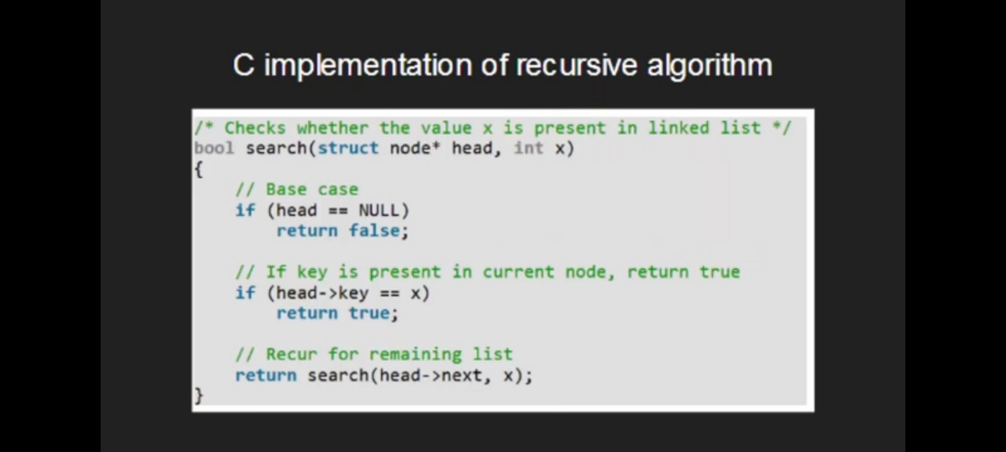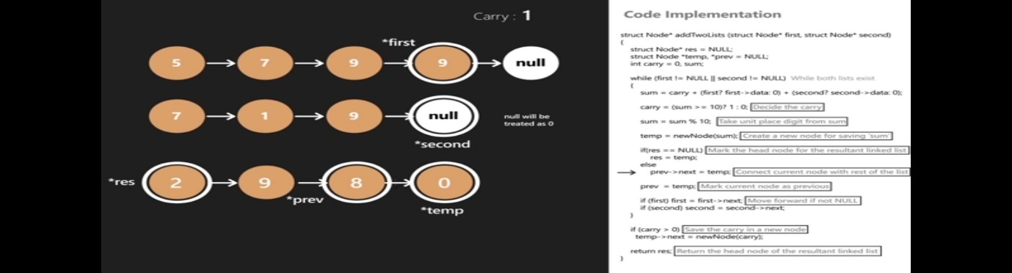

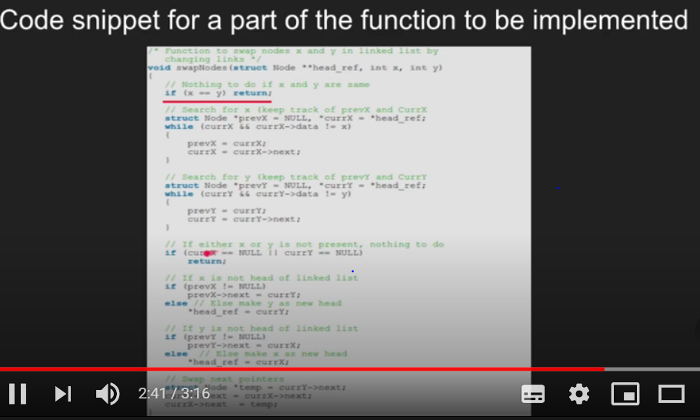

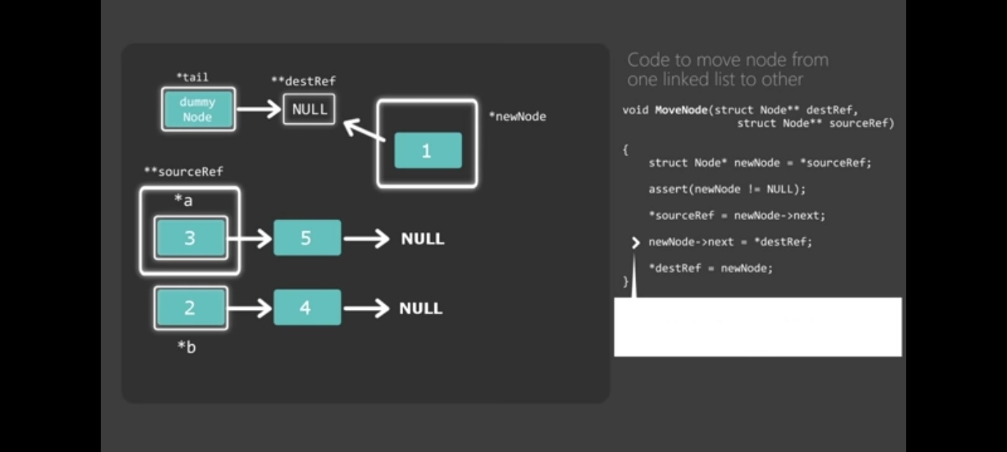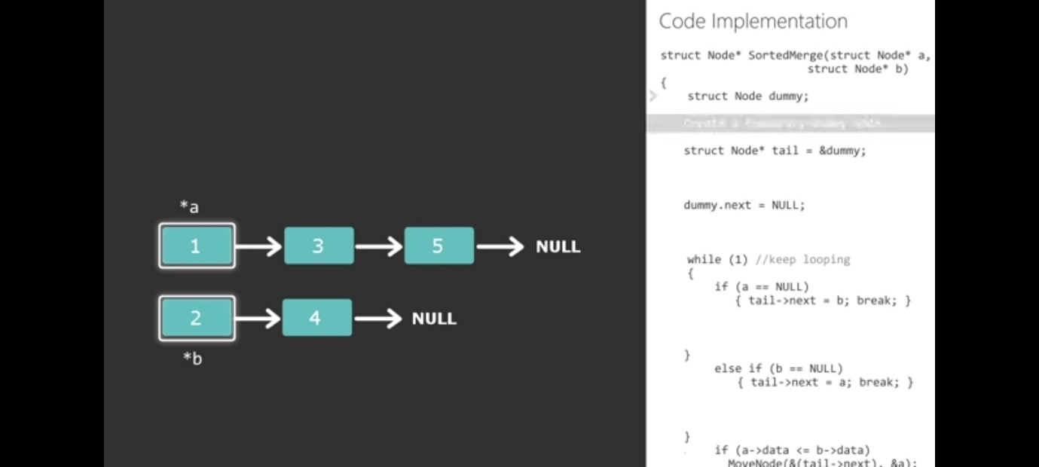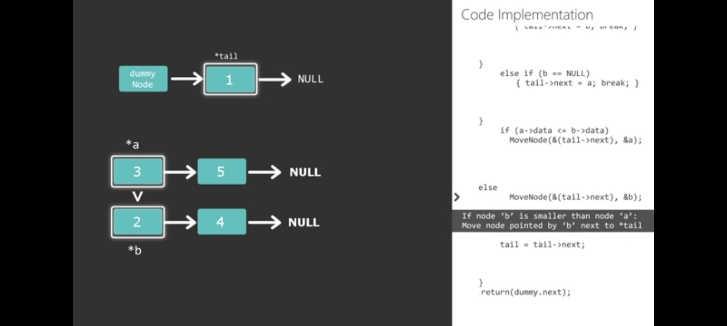
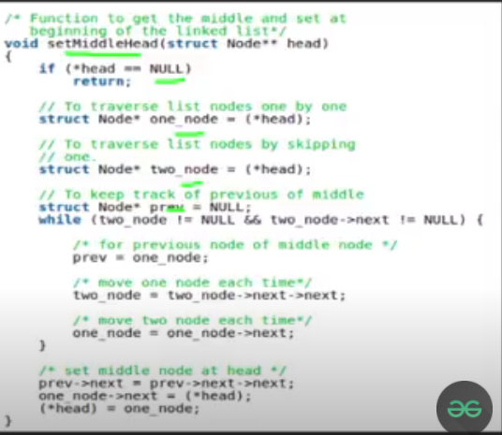
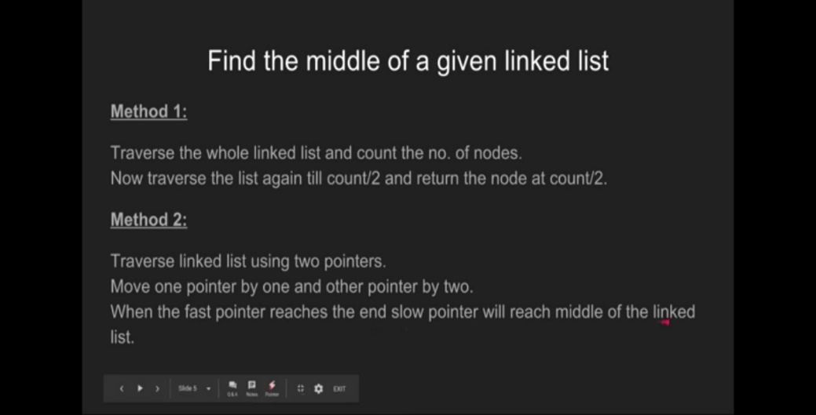
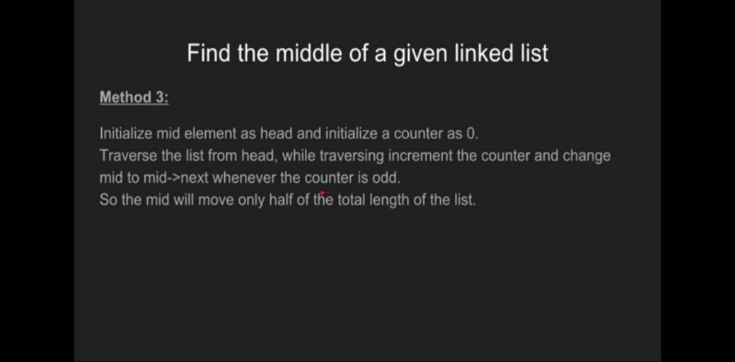
The idea is to first find middle of a linked list using two pointers, first one moves one at a time and second one moves two at a time. When second pointer reaches end, first reaches middle. We also keep track of previous of first pointer so that we can remove middle node from its current position and can make it head
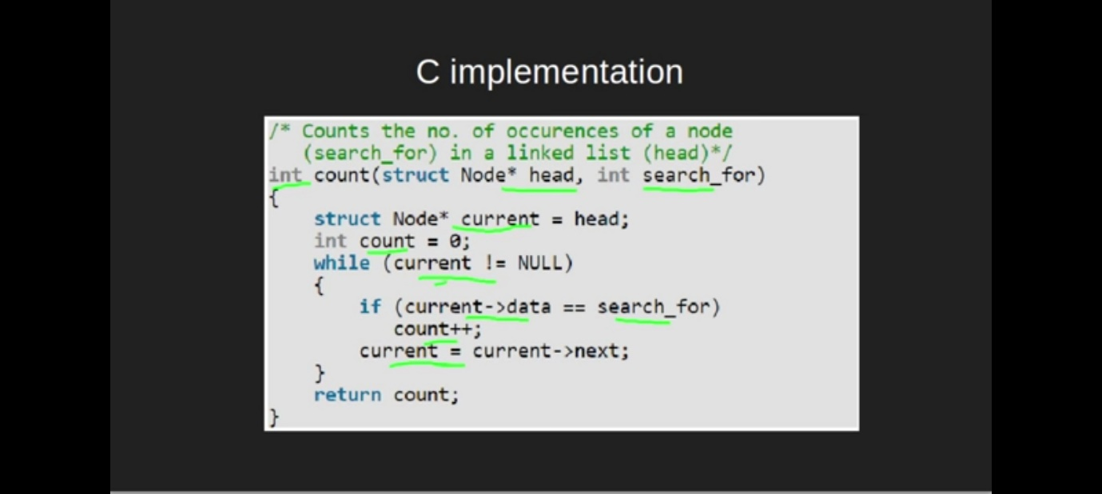

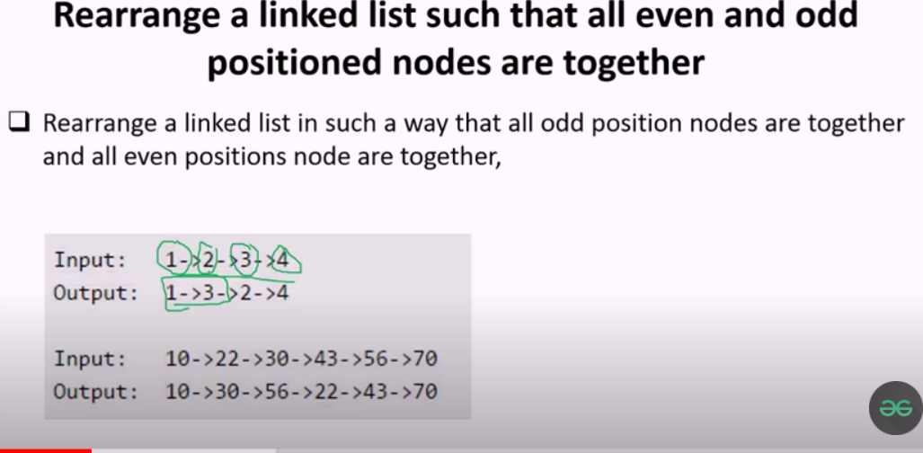


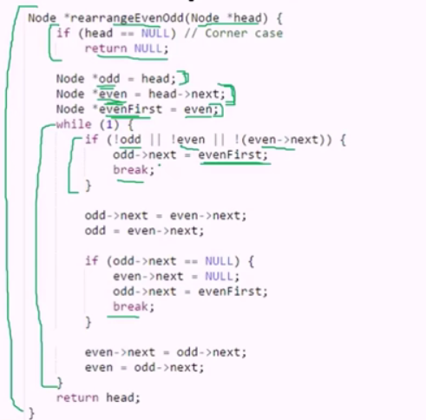
Video to detect and remove loops in linked list
https://youtu.be/_BG9rjkAXj8?list=PLqM7alHXFySH41ZxzrPNj2pAYPOI8ITe7
https://www.geeksforgeeks.org/detect-and-remove-loop-in-a-linked-list/

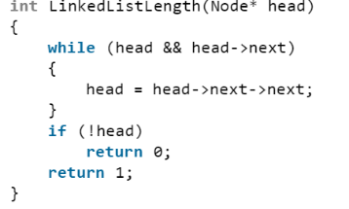
method to check whether list has even number of elements or odd
Method 1: Count the codes linearly
Traverse the entire Linked List and keep counting the number of nodes.
As soon as the loop is finished, we can check if the count is even or odd. You may try it yourself.
Method 2: Stepping 2 nodes at a time
Approach:
1. Take a pointer and move that pointer two nodes at a time
2. At the end, if the pointer is NULL then length is Even, else Odd

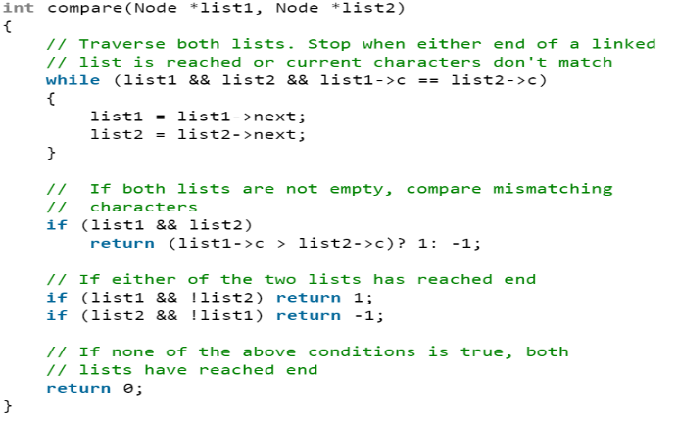
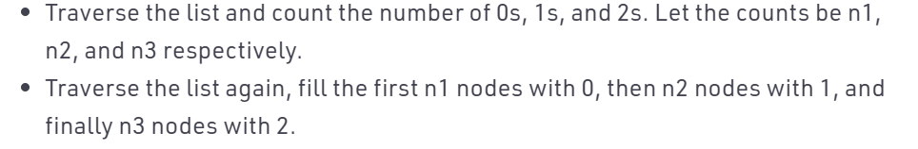
To compare two strings in list Sort list of zeros and ones

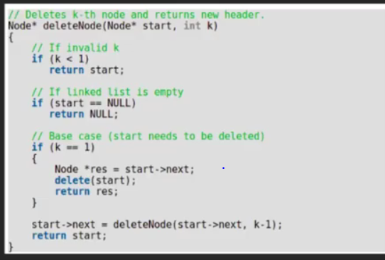
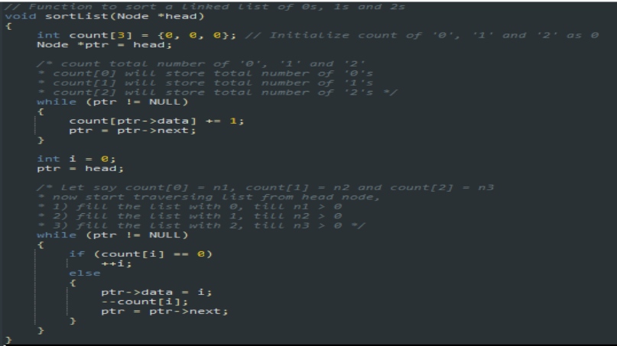
Time complexity is o(n) and space is o(1)

COUNTING OF ELEMENTS OCCURRENCE PROBLEM TO BE DONE USING HASH MAP;

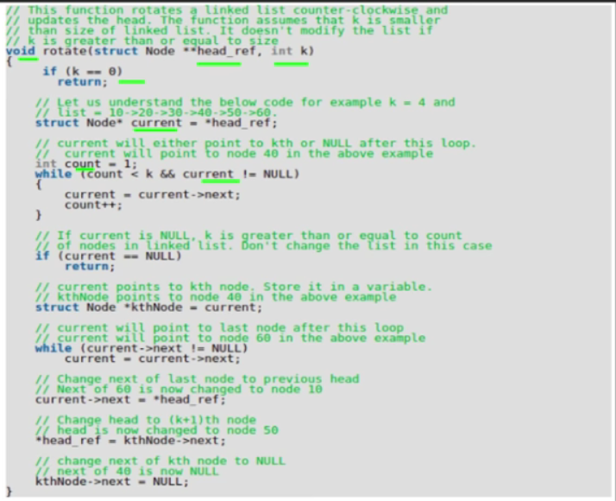
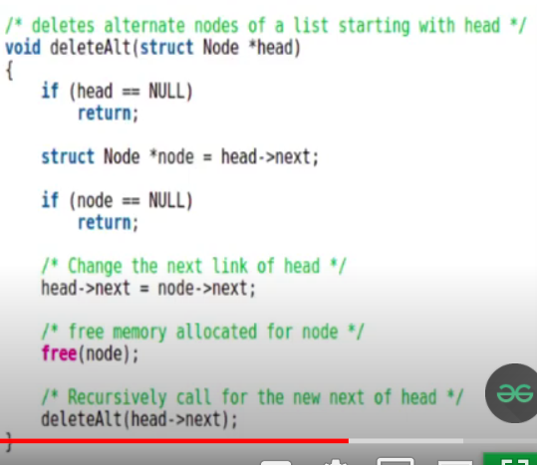
Delete kth node using recursion

